Slovak Orienteering Association
Junácka 6, 832 80 Bratislava - Slovakia

INVITATION

Bulletin 1

Slovak MTBO Championships 2012 - middle + long distance
World Ranking Event
Slovak MTBO Cup - 1st and 2nd round
Czech MTBO Cup - 1st and 2nd round
Hungarian MTBO Cup - 1st and 2nd round

Public MTBO Competition

Organizer: Šaštín-Stráže city and Slovak Orienteering Federation, Junácka 6, Bratislava – www.orienteering.sk

Technical Realisation: ŠK VAZKA Bratislava - www.vba.sk

Event date: 28 April – 29 April 2012

Event Centre: recreation area Gazárka, Šaštín-Stráže - http://g.co/maps/hdrxs

Competition rules: IOF MTBO rules 2012

Maps: special for MTBO (Lásek, scale 1:15 000), older maps of the location can be found on map portal - http://maps-new.orienteering.sk/ as well as attached at the end of this document

Embargoed areas: complete location of protected landscape area Zahorie, see the map at http://g.co/maps/hdrxs

Registration: Saturday (28 April 2012) 10:00 - 11:30 at the event centre
Sunday (29 april 2012) 08:00 - 09:00 at the event centre
Start 00: Saturday – 13:00 middle distance
Sunday – 10:00 long distance

Clasification of races: Saturday, 28 April – World Ranking Event in middle distance, individual start
Sunday, 29 April – World Ranking Event in long distance, individual start

Categories: Hungarian Cup:
W -14, W 15-17, W18-20, W 21-, W 40-, W 50-;
M-14, M 15-17, M 18-20, M 21-, M 40-, M 50-; M 60-
Note: categories M 21- and W21- will be automatically part of WRE races
Open categories: OPEN short (short and easy orienteering),
OPEN long (longer distance, easy orienteering),
NÁBOR ( very easy orienteering for total beginners)

Start fees:

Caterogies | till 31.3.2012 | till 15.4.2012 | from 16.4.2012
NÁBOR | 1 EUR / deň | 1 EUR / deň | 1 EUR / deň
Open Short, Open Long | 3 EUR / deň | 3 EUR / deň | 3 EUR / deň
M-14,W-14 | 3 EUR / deň | 4 EUR / deň | 5 EUR / deň
M-17,W-17,M-20,W-20 | 5 EUR / deň | 8 EUR / deň | 10 EUR / deň
W 21E, M 21E | 10 EUR / deň | 15 EUR / deň | 20 EUR / deň
Others | 7 EUR / deň | 10 EUR / deň | 15 EUR / deň

Applications: online system http://mtbo.vba.sk . Applications after the last deadline and/or at the event centre enabled by the conditions of organizers

Punching system: Sportident chip, SI chip rent at the registration for the fee 1 EUR/day

Terrain: mostly flat, several undulating partwith short and steep ups and downs, sandy ground, high density of tracks and paths

Price giving ceremony: Saturday – 18:00
Sunday – 12:30

Accomodation: Cottages for 4, 5 and 6 persons at the event centre, total capacity of 320 persons. Camping possibilities at the event centre as well.
Accomodation in gym will be also available, 2 km from event centre. Reservations to be made via online application system.

Parking: at the event centre

Catering: Restaurant - Pizzeria Tropic at the event centre - http://www.tropicpizza.com/

Attention: Cycling helmet is compulsory!
Organizers are not responsible for any damages caused during or after the competition. Each competitor is competing on his/her own will and on his/her own risk and is responsible for his/her health conditions.

Further info: http://mtbo.vba.sk , prihlaska@vba.sk

Organizing committee:
Event director: Miroslav Lago, lago@vba.sk, +421 905 547612
Course setters: Stanislava Fajtová, Mikuláš Šabo, Peter Mlynárik
Main refferee, National advisor: Marian Kazík
IOF and Czech Cup advisor: Jan Urban
Orientation map

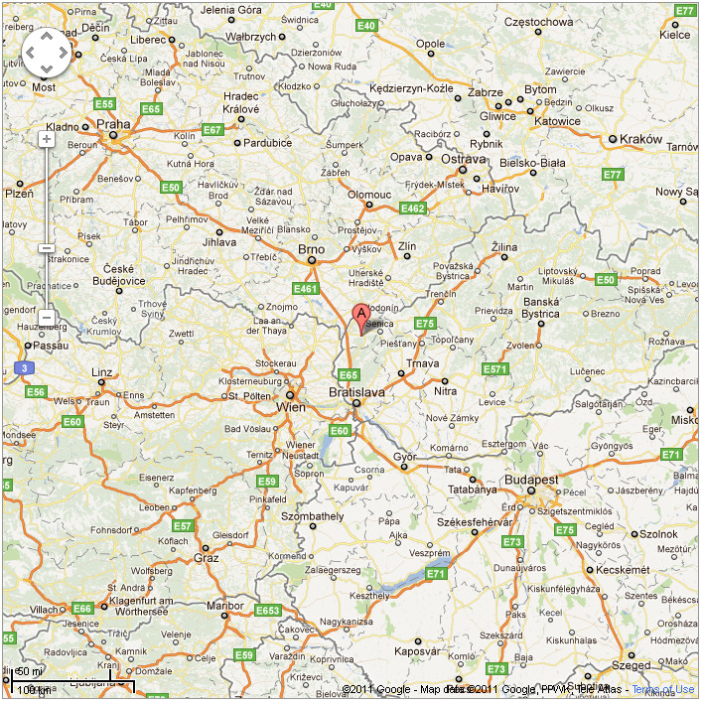
A = Šaštín – Stráže

Embargoed area
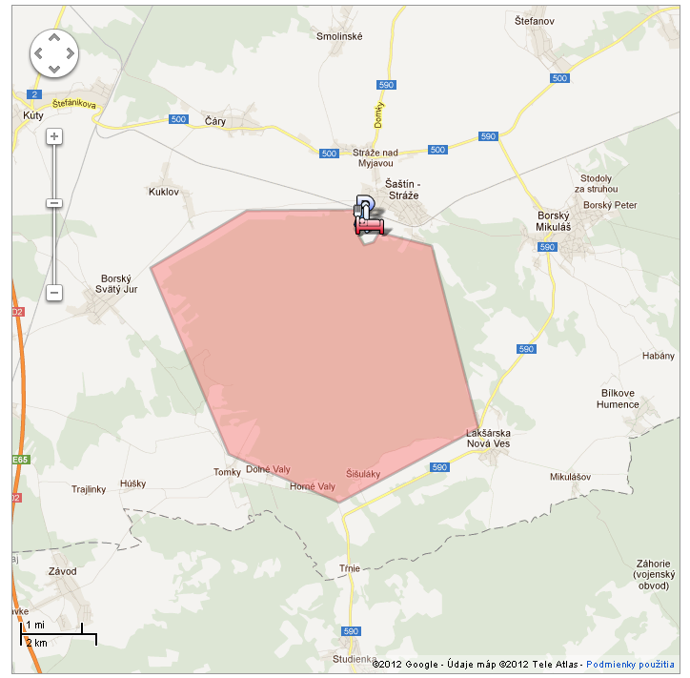
Older maps

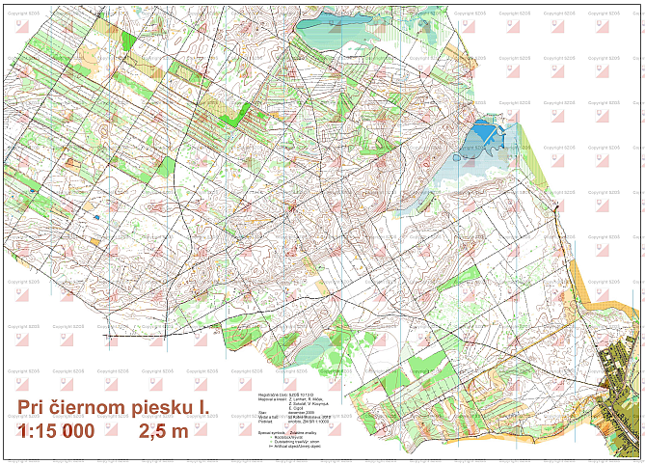

http://maps-new.orienteering.sk/mapy/mapa/mapa.php?j=sl&id=1010

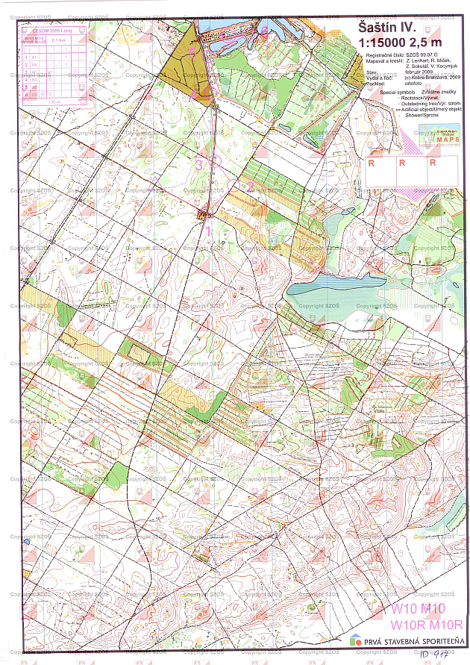

http://maps-new.orienteering.sk/mapy/mapa/mapa.php?j=sl&id=917

